Ch 11 project

Goals:

1. Understand and use delegates as function pointers
2. Understand and implement events
3. Understand Actions, Function and Lambdas

To exercise all these concepts, you’ll create the following classes/delegates:

A screenshot of a social media post

Description generated with very high confidence

The LoanPortfolio class maintains a generic collection of the Loan class. You’ll write a console application (i.e. the Program class in the diagram above) that will add loans, make payments, do bulk actions to every loan in the portfolio and log all events to the console.

Here’s a sample run of the application:

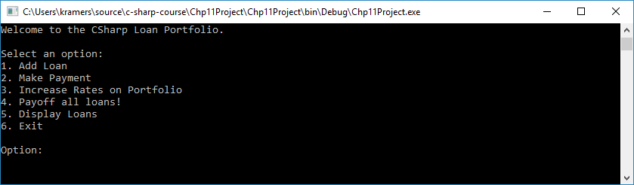

Enter option 1 Add Loan:

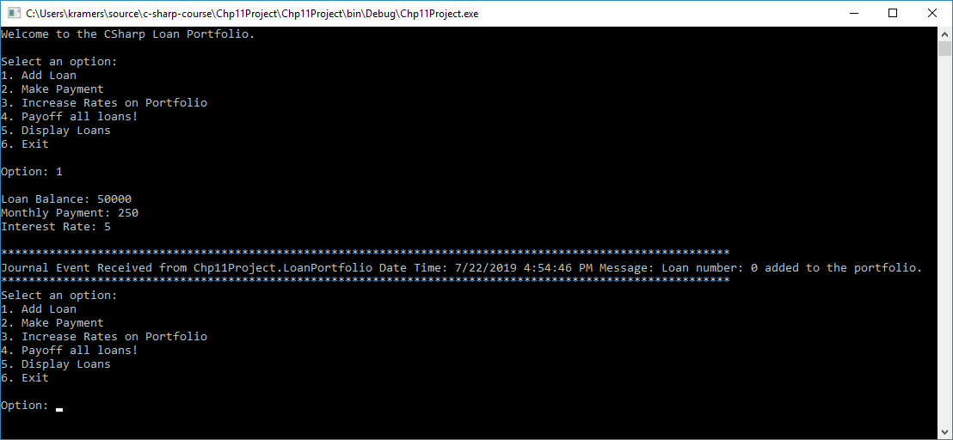

Display all loans:

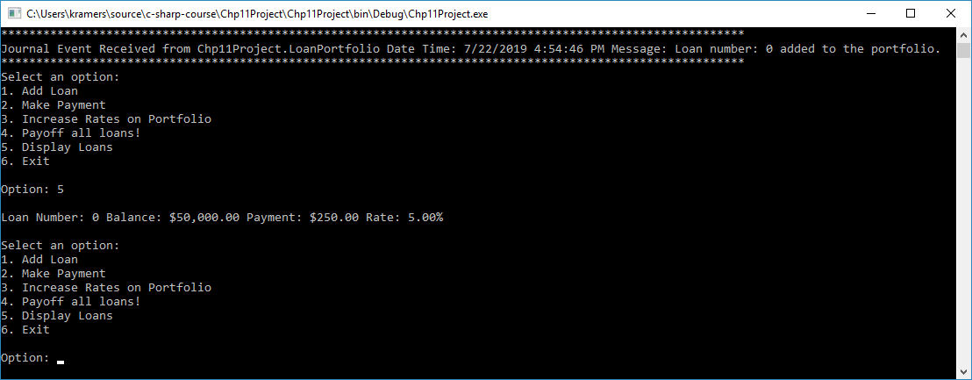

Make a payment:

